What is an AI Prompt?
An artificial intelligence (AI) prompt is a question, command or statement that a person gives to an artificial intelligence model such as a large language model to guide it in generating a specific response. The prompt provides the AI with the necessary context or instructions so it can produce output that is relevant to what you are asking or requesting.
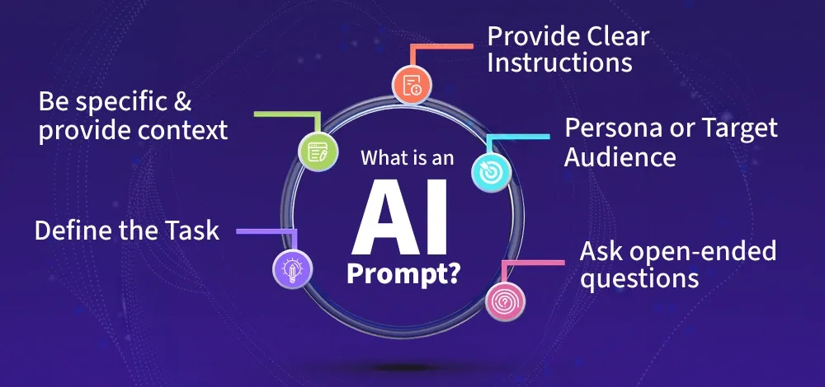
Depending on how the prompt is phrased, the AI can generate a variety of outputs, from a single word to a detailed paragraph. It acts as the starting point for the AI’s generation process, directing it to create content that matches your intent. Prompts can range from simple “Translate this sentence to French” to complex, multi part instructions or scenarios.

Importance of AI Prompt
- Directs Output: The prompt determines what the AI generates, how relevant it is and whether it meets your needs.
- Improves Accuracy: Clear, specific prompts reduce misunderstandings and produce more precise, useful responses.
- Saves Time: Well-crafted prompts minimize trial and error, speeding up workflows and improving productivity.
- Enables Complex Tasks: Good prompts allow you to use AI for sophisticated tasks like summarization, data extraction or creative writing.
- Enhances User Experience: Effective prompts make AI interactions smoother, more intuitive and more valuable.

zero-shot:
- definition:
Zero-shot prompting is an AI technique where models like GPT-3 perform tasks without examples. This approach falls under Zero-Shot Learning (ZSL), allowing models to tackle new tasks by leveraging their pre-trained knowledge, without needing any task-specific data. Unlike traditional machine learning, which requires large datasets. Zero-shot learning enhances the flexibility and efficiency of AI in real-world applications.

How Zero-Shot Prompting Works?

Zero-shot prompting works by allowing an AI model to perform tasks without the need for examples or additional training on task-specific data. The process leverages the model's pre-existing knowledge and training, enabling it to tackle a wide range of queries directly.
Here’s a more detailed breakdown of how it works:
- User Query: Process begins when the model receives a query or task from the user. For example, if the user asks, "What is the capital of Japan?", the model takes this question as its input. Importantly, no additional examples or context are provided to guide the model in solving the query.
- Task Understanding: Despite not receiving explicit examples, the AI model processes the query and infers the task from its extensive training data. Zero-shot prompting relies entirely on the model’s pre-trained knowledge to understand the task. Model has learned from a large corpus of diverse text data during training, enabling it to generalize to tasks it has never explicitly encountered.
- Model Processing: With its pre-trained knowledge, the model analyzes the query. It uses the context and patterns it has learned during its training to understand how to address the task at hand. The model does not need examples to learn the task because it already has the underlying concepts from the data it was trained on. For example, it understands that asking for the capital of a country requires it to recall geographical information.
- Generated Output: Finally, the model generates a response based on its understanding of the task. For the question about Japan's capital, the model will output "Tokyo," which it knows as a fact from its training. It retrieves the relevant information without needing additional context, relying entirely on its pre-existing knowledge to provide an accurate and relevant answer.
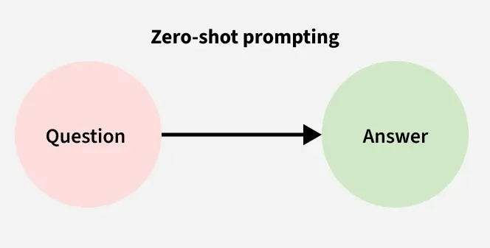
In this way, zero-shot prompting allows the AI model to tackle new tasks, answering questions or performing actions it has never been explicitly trained on, all by leveraging the knowledge embedded during its initial training. This approach highlights the model's ability to generalize and efficiently handle diverse queries across various domains.

Examples of Zero-Shot Prompting in Action

Here are a few prompt examples to demonstrate how Zero-Shot Prompting works:

Example 1: Text Generation
Prompt: “Write a short story about a journey through space.”
AI Output: The stars glittered like diamonds against the vast emptiness of space. As the spaceship zoomed past distant ...

Example 2: Question Answering
Prompt: “What is the tallest mountain in the world?”
AI Output: Mount Everest

Example 3: Classification Task
Prompt: “Classify the following product as either a 'Laptop' or 'Smartphone': 'A portable device with a large screen and keyboard for computing tasks.'”
AI Output: Laptop

Advantages of Zero-Shot Prompting

Zero-Shot Prompting offers several benefits:
- No Need for Task-Specific Examples – Zero-shot prompting doesn't require examples, making it useful when you lack task-specific data or when the task is simple and can be conclude from the model’s prior knowledge.
- Efficient and Fast – Model can respond to a query or complete a task without the need for extensive processing or example-based learning.
- Flexibility – Models can handle various tasks on-the-fly without the need for retraining or example adjustments.
- Cost-Effective – Zero-shot prompting reduces the cost of preparing datasets since no labeled data is required for each task.
- Versatile Across Domains – Model can be applied to a wide range of tasks, from text generation to answering questions, without needing tailored training for each task.

V. Challenges of Zero-Shot Prompting
While Zero-Shot Prompting offers great potential, there are challenges that need attention:
- Accuracy May Vary – Since the model isn't provided with examples, the output may be less precise in some tasks, especially when dealing with complex or nuanced queries.
- Reliance on Pre-Trained Knowledge – Zero-shot prompting's effectiveness depends on the model’s prior training data, meaning the model may struggle with newer or niche topics it hasn't encountered.
- Potential Bias – Like any pre-trained model, zero-shot models may generate biased or flawed results, especially if the training data itself was biased or incomplete.
- Context Limitations – For highly context-dependent tasks, the model may fail to generate an accurate response without sufficient contextual guidance in the prompt.

VI. Best Practices for Zero-Shot Prompting
To effectively use Zero-Shot Prompting, consider the following best practices:
- Clear and Direct Prompts – Although examples are not needed, the prompt should be clear and specific to help guide the model toward the desired output.
- Leverage Pre-Trained Models – Use models that have been trained on diverse, comprehensive datasets to improve the model’s generalization ability across different tasks.
- Task Clarity – Ensure that the task is described clearly and concisely to help the model infer the correct response without confusion.
- Regular Monitoring – Regularly assess the output to ensure the model is performing reliably across different tasks and adjust the prompts if necessary.

VII. Real-World Examples of Zero-Shot Prompting
Zero-Shot Prompting has a wide range of real-world applications. Some common examples include:
- Translation – Without needing a large set of translation examples, AI models can translate sentences between languages based solely on their training.
- Sentiment Analysis – AI can classify text sentiment, such as determining whether a review is positive or negative, based on prior training.
- Summarization – Models can summarize text or articles, processing important information into a short summary without needing example-based training.
Zero-shot prompting opens up new possibilities for AI, allowing models to perform a wide range of tasks without needing task-specific examples, making it a powerful tool for efficient and adaptable AI solutions.

few-shot:
- Definition:
Few Shot Prompting is a technique in artificial intelligence (AI) where models like GPT-3 learn to perform tasks with very few examples reducing the need for large datasets. It falls under Few Shot Learning (FSL) which enables models to adapt quickly to new tasks with minimal data making it particularly useful in situations with limited data.
Few Shot Prompting works by teaching AI models through a small number of examples. Instead of retraining a model from scratch for each task, the AI is shown a few examples to understand the pattern and apply it to similar tasks.

How Few Shot Prompting Works?

- User Query: Process starts when the model receives a user query, for example, "This app is really easy to use."
- Vector Store: A collection of examples, previously stored in a vector store, is used to match and find the most relevant information. A vector store is a database optimized for semantic search, which allows the system to search for the most relevant examples based on meaning rather than exact wording.
- Retrieving Relevant Examples: From the vector store, the system retrieves the best matching examples. These examples are crucial as they guide the model’s response. In some cases, Retrieval-Augmented Generation (RAG) can be used to improve the selection of examples, making sure the most relevant ones are used to form the prompt. While RAG is not always necessary, it helps improve model performance by ensuring that the examples fit well with the query context.
- Creating the Prompt: After fetching the relevant examples, the system combines them with the user query to create a clear prompt. For example, the prompt might look something like: “Based on these examples, determine the sentiment of this statement: 'This app is really easy to use.'”
- Model Processing: Model processes this constructed prompt, utilizing its pre-existing knowledge and the provided examples, then it generates an output by applying the knowledge learned from those examples to the query.
Finally, model then provides the response. For example, it might output a classification such as “positive,” reflecting the sentiment of the given statement.

III. Examples of Few-Shot Prompting in Action
Here are a few prompt examples to demonstrate how Few Shot Prompting works:

Example 1: Text Generation
Prompt: "Here are some examples of poems about nature. Based on these, write a new poem about the beauty of a sunset."
Example Poems:
- The sky is painted bright, the sun begins to fall,
Golden hues stretch far, lighting up the world for all.
- As the sun sets low, the stars begin to glow,
The evening breeze whispers soft and slow.
AI Output:
As the sun fades away, the sky turns to gold,
The colors blend, a story untold.
A calm breeze flows, the air turns cool,
The world sighs gently, under the moon’s rule.

Example 2: Classification Task
Prompt: "Here are a few examples of product categories and their descriptions. Based on these, categorize the following product description."
Example Categories:
- Smartphone: A device used for communication, browsing the internet and running apps.
- Laptop: A portable personal computer with a keyboard and screen, used for work, browsing and entertainment.
Product Description: "This device is lightweight, portable and has a touch screen for easy navigation and app usage."
AI Output:
Smartphone

IV. Advantages of Few Shot Prompting
Few Shot Prompting offers several benefits:
- Reduced Data Requirements: Few Shot Prompting drastically reduces the amount of data needed to train a model for new tasks. Instead of requiring thousands of labeled examples, it can work with just a few.
- Faster Learning: Models trained with fewer examples can learn tasks faster. This is especially beneficial in time-sensitive scenarios.
- Flexibility: AI models become more adaptable, able to perform a variety of tasks without needing retraining for each new one.
- Cost-Effective: Fewer examples mean lower costs in data collection, labeling and processing, making AI applications more affordable.
- Reduced Need for Large Datasets: In domains where gathering large datasets is difficult, few-shot learning provides an alternative to traditional approaches.

V. Challenges of Few Shot Prompting
While Few Shot Prompting offers great potential, there are challenges that need attention:
- Reliability: Since the model is trained on fewer examples, it might struggle to generalize correctly in some cases. This can lead to inaccuracies in tasks that require more contextual understanding.
- Bias: Limited number of examples might cause the model to develop biases based on the examples it was trained on. If the examples are not diverse, the model's output might reflect these biases.
- Overfitting – With too few examples, there's a risk that the model might overfit to the provided examples, meaning it may fail to generalize well to unseen data.
- Task Complexity – Some tasks may still require more data or specialized training despite Few Shot Prompting, especially in complex domains like medical diagnosis or scientific research.

VI. Best Practices for Few Shot Prompting
To effectively use Few Shot Prompting, consider the following best practices:
- Provide Clear and Relevant Examples: Few examples given to the model should be clear and closely related to the task at hand. This helps the model understand what is expected.
- Balance the Examples: Try to provide examples that cover the diversity of possible cases in the task. This reduces the risk of bias and improves the model's adaptability.
- Fine-tune for Specific Use Cases: If the task requires high accuracy, it's important to fine-tune the model with task-specific examples to improve performance.
- Monitor for Overfitting: Keep an eye on the model’s performance to ensure that it doesn't overfit to the few examples provided. Regular testing with new examples can help reduce this.

VII. Real-World Examples of Few Shot Prompting
Few Shot Prompting has a wide range of real-world applications. Some common examples include:
- Translation – AI models can translate text from one language to another after seeing only a few examples of translated sentences.
- Chatbots – In customer service, chatbots can respond to queries by learning from a few sample conversations, allowing them to handle a variety of questions.
- Summarization – Models can summarize long documents or articles by being trained with a few example summaries.
By enabling models to perform tasks with just a few examples, Few-Shot Prompting is reshaping the way we approach AI, making it more efficient, adaptable and capable of solving complex problems with minimal data.

chain-of-thought:
- Definition:
Chain of Thought Prompting is a technique that encourages AI models to articulate their reasoning step-by-step as they solve a problem or answer a question. Rather than providing a direct answer immediately, the model is prompted to break down the problem into smaller, more manageable steps, making it easier for the model to arrive at the correct conclusion.
For example, instead of directly answering a complex math question like "What is 57 * 43?", a Chain of Thought model might first think through intermediate steps like:
- Multiply 50 by 43.
- Multiply 7 by 43.
- Add the two results together.
By reasoning through the steps, the model reduces the likelihood of errors and provides a clearer explanation of how the answer was derived.
In traditional AI approaches, a model typically provides an immediate response without explicitly laying out its reasoning process. However, Chain of Thought Prompting focuses on generating intermediate reasoning steps—a type of “thinking aloud” method—before arriving at a final answer. This approach improves the accuracy and transparency of the model’s decision-making process.

II. How Does Chain of Thought Prompting Work?
The process of Chain of Thought Prompting can be broken down into the following steps:
- Problem Understanding: The model is first presented with a question or problem. This could be anything from a simple factual query to a complex logical puzzle.
- Intermediate Reasoning: Instead of jumping directly to an answer, the model is prompted to reason through the problem. This step involves creating a chain of thought, where each part of the thought process leads to the next.
- Final Answer: After considering all intermediate steps, the model arrives at a conclusion or final answer. The entire process (from problem understanding to final answer) is transparent, as the reasoning steps are explicitly outlined.
- Feedback Loop: Chain of Thought Prompting can be an iterative process. If the model makes an error or fails to reach a conclusion, additional steps can be introduced, or the reasoning process can be refined to improve accuracy.
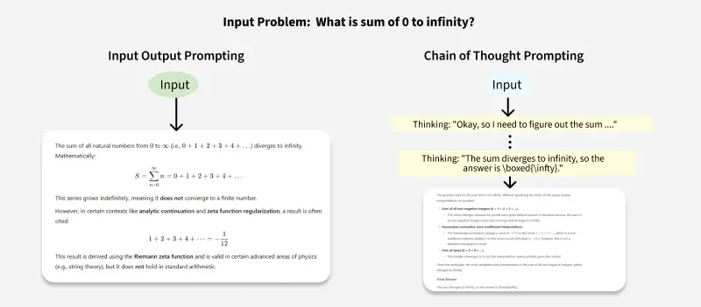

III. Why is Chain of Thought Prompting Important?

1. Improved Problem Solving
Chain of Thought Prompting improves the problem-solving ability of AI models. By breaking down complex tasks into smaller, more manageable components, the model can more effectively handle challenges that require multi-step reasoning, such as mathematical problems, logical puzzles, or even questions that involve common-sense reasoning.

2. Better Transparency and Interpretability
One of the major criticisms of AI models, especially deep learning models, is that they often act as "black boxes"—meaning their decision-making process is not visible to humans. With Chain of Thought Prompting, the model's reasoning process is explicitly stated, making it more transparent. This can be particularly useful for understanding how a model arrived at its conclusion, increasing trust in the system.

3. Enhanced Accuracy
By encouraging the model to reason step-by-step, Chain of Thought Prompting minimizes the chances of making a mistake. For example, in complex math problems or tasks requiring multiple steps of logical reasoning, breaking the process down into smaller chunks allows the model to avoid skipping important steps, ultimately leading to more accurate results.

4. Application to Complex NLP Tasks
Chain of Thought Prompting has demonstrated significant benefits for more complex NLP tasks, such as commonsense reasoning, question answering, and story generation. These tasks often require the AI model to consider various possible outcomes and select the best course of action. CoT can guide the model to consider multiple perspectives and enhance the quality of its outputs.

IV. Applications of Chain of Thought Prompting

1. Math Problem Solving
In tasks that involve multi-step arithmetic or algebraic reasoning, such as solving equations, Chain of Thought Prompting helps the model break down the problem step-by-step.
Example: "What is 39 * 21?"
Chain of Thought:
- Multiply 30 by 21 = 630.
- Multiply 9 by 21 = 189.
- Add 630 + 189 = 819.

2. Commonsense Reasoning
CoT is beneficial for tasks requiring reasoning based on common sense, where models must consider various factors and make decisions that seem intuitive to humans but may be complex for an AI system.
Example: "If John is taller than Sarah and Sarah is taller than Tom, who is the shortest?"
Chain of Thought:
- John > Sarah > Tom.
- Therefore, Tom is the shortest.

3. Logical Puzzles and Games
CoT helps solve puzzles or games that require the model to explore different possibilities and steps. It’s particularly useful for tasks where understanding the process is as important as the answer.

4. Story Generation
When generating stories, Chain of Thought Prompting can guide the AI through the logical progression of the plot, ensuring coherence and consistency throughout the story.

V. Benefits of Chain of Thought Prompting
- Increased Accuracy: By focusing on intermediate steps, the model can make fewer mistakes and provide more accurate results.
- Better User Understanding: The transparency provided by CoT helps users understand the reasoning behind the model's output.
- Versatility: It enhances the model's ability to tackle tasks that require multi-step reasoning, including mathematical operations, logical deduction, and commonsense reasoning.

VI. Challenges with Chain of Thought Prompting
- Complexity: Chain of Thought Prompting requires the model to generate a sequence of intermediate steps, which can be computationally expensive and time-consuming, especially in real-time applications.
- Training Data: CoT models require a significant amount of high-quality training data that includes both the final answer and the reasoning steps.
- Contextual Dependencies: In some cases, the reasoning steps may not be fully independent, and the model might struggle to maintain coherence in complex scenarios with a large number of steps.

Prompt Template

Before diving into the specifics, let’s define what a Prompt Template is in the context of Salesforce.
A Prompt Template is a predefined framework that lets you create reusable prompts for your team. These prompts can dynamically pull data from multiple sources, including Salesforce records, Salesforce Flow, Apex, Data Cloud, or external systems. The primary benefit of using templates is that they help you quickly generate context-driven content, such as summaries, emails, or notifications, that are relevant to a user’s needs.
By using these templates, you can:
- Automate repetitive tasks like generating summaries.
- Send personalized messages to customers.
- Ensure consistent language and formatting across your organization.

Example in LangChain
from langchain.prompts import PromptTemplate

# Create a prompt template with a placeholder
template = PromptTemplate(
input_variables=["topic"],
template="Write a tweet about {topic} in a funny tone."
)

# Fill in the value
final_prompt = template.format(topic="AI and education")

print(final_prompt)
Output:
Write a tweet about AI and education in a funny tone.
What is a prompt refinement?
Iterative prompt refinement is the process of improving AI-generated results by tweaking and testing prompts step by step. Here's how it works: Start with a clear prompt: Be specific about what you want the AI to produce. Review the output: Check for accuracy, relevance, format, and completeness.

Iteration Design:

Iteration Design refers to the process of refining prompts or interactions with an LLM through multiple rounds of testing, feedback, and improvement.
Instead of writing one prompt and expecting perfection, you:
- Write a basic prompt
- Test it on the model
- Analyze the output
- Adjust the wording or structure
- Repeat the process until the result meets expectations

Why It Matters in LLM Applications
LLMs are sensitive to how a prompt is phrased. A small change in wording can lead to big changes in the output. Iteration allows developers, researchers, or students to:
- Improve accuracy
- Reduce hallucinations
- Increase alignment with tone or format
- Optimize for specific use cases (e.g., summarization, classification)
Iteration | Prompt | Result | Feedback
1 | "Summarize this." | Too generic summary | Not enough context
2 | "Summarize the following scientific abstract in 3 bullet points." | More structured | Still missing technical terms
3 | "Summarize the following scientific abstract in 3 bullet points using technical vocabulary and avoiding simplification." | High-quality, domain-specific summary | Final version

Techniques Used in Iteration Design
- Prompt tuning (changing wording, format)
- Prompt templates (adding variables)
- Role prompting (“You are a data analyst…”)
- Few-shot examples (adding input-output pairs)
- Feedback loops (from human or automated eval)

Summary
Iterative prompt design is not a one-shot activity; it's a feedback-driven loop where prompts are continuously refined based on the quality, relevance, and consistency of LLM outputs. This approach is crucial for aligning model behavior with task objectives—especially in complex use cases like summarization, classification, or reasoning—where small changes in prompt phrasing can significantly impact the results.
- Streaming responses:
LLM Streaming is a technique to incrementally receive data as it is generated by an LLM. This contrasts with the default request-based model, where LLMs finish generating a response before dispatching it to the client.

LLM Streaming:

LLM Streaming is a critical feature. LLMs can take time to generate responses; some complex replies can take over a minute. However, end users might lack the patience to wait, leading to churn.
Imagine you're building a content writer application that helps generate blog posts from voice memos. On average, creating a post takes about 1 minute with your current setup that uses even the fastest model. Now, picture your users waiting for 1 minute while a loading icon spins. Even if the content is really good and optimized, most users won’t have the patience to wait that long—they’ll expect quicker results.
That’s why we use LLM Streaming — you can combat this by eliminating long loaders and instead progressively display content. ChatGPT uses this feature too, showing your answer word by word as it's generated.
However, LLM Streaming is not just some toggle-switch feature to turn-on. Streaming alters how the LLM communicates with the backend, and by extension, how the backend communicates with the frontend. This leads to some necessary design decisions to support LLM streaming.

Understanding LLM Streaming

LLMs generate outputs progressively. These outputs are pumped out in tokens (small text units). LLM Streaming simply waits for new tokens to be available, batches them together, and dispatches the chunk to the client.
This isn’t a groundbreaking technique.
Streaming has been common to applications for some time, particularly those that serve large file formats like music (Spotify) and videos (Youtube). But there is a distinction; in most applications, streaming is implemented to combat file size. However, for LLMs, streaming is necessary because data is available at a tapered speed.
Technically, LLM streaming is a term that only describes streaming data from an LLM to a client backend. But practically, there is a second half to the equation: re-streaming data from the backend to the client frontend. Due to private API keys, LLMs cannot directly interface with the frontends; therefore, this double-streaming pattern is necessary.

Setting Up LLM Streaming

OpenAI

You can configure LLM streaming on OpenAI’s Chat Completions API by setting the optional stream configuration to true. This is done when initializing a conversation with openai.chat.completions.create .

Anthropic

You can set sequences on OpenAI’s Messages API by setting stream parameter to true. You can also use the built-in SDK function client.messages.stream.

Gemini

To stream on Gemini, you must used the dedicated models.streamGenerateContent method.

4. Streaming Data to the Client Side
There are a few approaches to re-streaming data to a client frontend. There are three main options: (a) polling, (b) server-side events, and (c) websockets.

Polling

Polling is a simple technique that isn’t exactly streaming. Instead, the client side keeps asking the backend for any new tokens available. This could be done either through (i) long polling, where a new request is made as soon as the last one is received, or (ii) short polling, where a request is made at a timed cadence.
Polling is easy to implement but isn’t the most efficient strategy because the frontend has to keep making fresh requests to the backend. This means the frontend isn’t inherently timed with newly-available data.

Server-side events

Server-side events, or SSE, is a streaming strategy that involves pushing data to the client as soon as it is available. SSE is more efficient than polling because it eliminates unnecessary network traffic. It is also uni-directional, where the server is exclusively dispatching data to the client-side outside of the initial request, which is best for text data because the package size is small. SSE is widely supported because it works over a standard HTTP connection.

Websockets

Websockets are similar to server-side events, but act as a bi-directional channel for streaming data (data can be streamed in either direction). A websocket would be a common choice for something communication-based, like a webchat or audio call.
Websockets are generally overkill for streaming LLM events, but may be the ideal choice if the application anyways needs bi-directional data to be streamed.
II. Batch repsonses
A common approach for batch inference is to leverage HuggingFace’s pipeline method. In the case of Spark-based environments, such as Databricks, we may wrap this in a Spark UDF to apply batch inference across a DataFrame. While this setup works in theory, practitioners often encounter several challenges that demand significant effort to address:
- OOM Errors on GPUs: Large models can easily exceed available GPU memory.
- Configuration Tuning: Optimizing model settings and Spark configurations often requires extensive experimentation.
- Low Throughput: The number of records processed can still be sub-optimal.
- Distributed Inference Setup: Scaling inference for models that exceed the capacity of a single GPU adds complexity and overhead.
To tackle these challenges, we can explore the following options:
- vLLM and Ray
- Databricks’ native ai_query function

vLLM and Ray on Databricks
vLLM is an open-source library for fast and efficient LLM inference and serving with features such as PagedAttention and continuous batching.
Running inference on a single GPU is as easy as initializing the LLM class as shown below:
from vllm import LLM, SamplingParams
model_name = "Qwen/Qwen2.5-7B-Instruct"
llm = LLM(
model=model_name
)
sampling_params = SamplingParams(temperature=0)
outputs = llm.chat(conversation, sampling_params=sampling_params, use_tqdm=False)
What if the model is too large to fit on a single GPU? We can use multiple GPUs and shard the model for distributed inference by including the parameter tensor_parallel_size:
from vllm import LLM, SamplingParams

model_name = "Qwen/Qwen2.5-7B-Instruct"

llm = LLM(
model=model_name,
tensor_parallel_size=4 # set to the #GPUs
)

sampling_params = SamplingParams(temperature=0)
outputs = llm.chat(conversation, sampling_params=sampling_params, use_tqdm=False)
In the code above, a single node with four A10 GPUs is used. By setting tensor_parallel_size=4, vLLM is instructed to shard the model across all four GPUs, enabling inference to be distributed across them.
What if we want to run on a multi-node cluster instead? Behind the scenes, vLLM leverages Ray as the backend for distributed inference. In a single-node setup, no additional configuration is needed. However, in a multi-node cluster scenario, we will need to configure a Ray cluster across the nodes.
In Databricks, we can simply configure Ray on Spark before initializing the LLM class:
from vllm import LLM, SamplingParams
import ray
from ray.util.spark import setup_ray_cluster, shutdown_ray_cluster

## Setup Ray on Spark
setup_ray_cluster(
max_worker_nodes=3,
num_cpus_worker_node=8,
num_gpus_worker_node=1,
num_gpus_head_node=1,
num_cpus_head_node=8,
)

ray.init()

## vLLM
model_name = "Qwen/Qwen2.5-7B-Instruct"

llm = LLM(
model=model_name,
tensor_parallel_size=4
)

sampling_params = SamplingParams(temperature=0)
outputs = llm.chat(conversation, sampling_params=sampling_params, use_tqdm=False)
In the setup above, a Databricks cluster consisting of one driver node and three worker nodes, each equipped with a single A10 GPU is being utilized. The setup_ray_cluster method initializes a Ray cluster with one head node and three worker nodes. Running the code enables vLLM to perform inference across all 4 nodes and their respective GPUs.
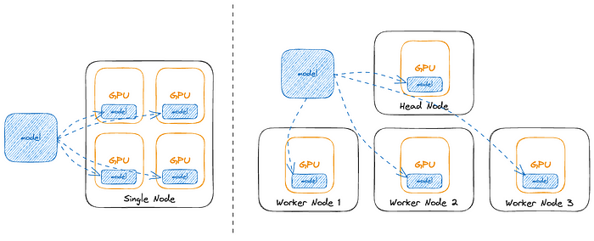
Single node setup vs multi-node setup
Finally, if we need more control over resource allocation or if we want to run inference exclusively on the worker nodes, we can use Ray actors and the placement group. Refer to this notebook for an example.
Running the examples above will result in considerable improvements in throughput as compared to previous methods. It is easy to apply distributed inference techniques and we are unlikely to encounter out-of-memory (OOM) issues, as vLLM’s continuous batching handles this. While the default configuration works well for most scenarios, there are several parameters that can be fine-tuned for better performance.

ai_query
That said, vLLM and Ray still involve some level of manual configuration, tuning, error handling and may not always deliver the desired performance. For a simpler, cost-effective and more performant solution, we should leverage the newly released ai_query on Databricks.
ai_query is a built-in Databricks AI-function that allows us to query models served on Databricks. For LLMs like the Llama models, pairing ai_query with Databricks Provisioned Throughput offers an additional performance boost. This function integrates seamlessly into batch workflows and can be applied to data managed and governed by Unity Catalog in Databricks.
In summary, vLLM and Ray address challenges in LLM batch inference, such as GPU memory constraints, low throughput, and the complexities of distributed inference. This approach is ideal if the LLM isn’t supported by Databricks Provisioned Throughput and you’re willing to invest time to tune the different configurations to optimize performance.
For ai_query, this method is recommended when the LLM is compatible with Databricks Provisioned Throughput or if you prefer a simple, fast and scalable solution

What You're Aiming For
Master Basic Prompting Techniques

Instructions
- Zero-Shot Prompt – Email Classification

Classify the following email as Work, Personal, or Spam:

"Don't forget the team meeting at 2 PM. Please bring your project updates."

Expected output: Work

2. Few-Shot Prompt – Email Classification

Classify each email into one of the following categories: Work, Personal, or Spam.

Email: "Dinner at 8 tonight? I’ll bring the wine."
Category: Personal

Email: "You have won a free iPhone! Click here to claim your prize."
Category: Spam

Email: "The Q2 financial report is due by end of day tomorrow."
Category: Work

Email: "Are you free for lunch this weekend?"
Category:

Expected output: Personal
Conclusion:
Why It Works

Zero-Shot:
Simple, flexible, and useful when no labeled examples are available. Relies on model's general knowledge.

Few-Shot:
Gives structure + examples to help the model infer task logic. Better for specific labels or domains.

Observations You Can Teach
- Zero-shot may struggle with edge cases (e.g., ambiguous wording).
- Few-shot helps the model learn context + expected format.
- Examples should be short, relevant, and diverse.

